1. Why this is? (When an expert has not added his session charges and that expert is being shown in the listing, then it is shown as not-available.)

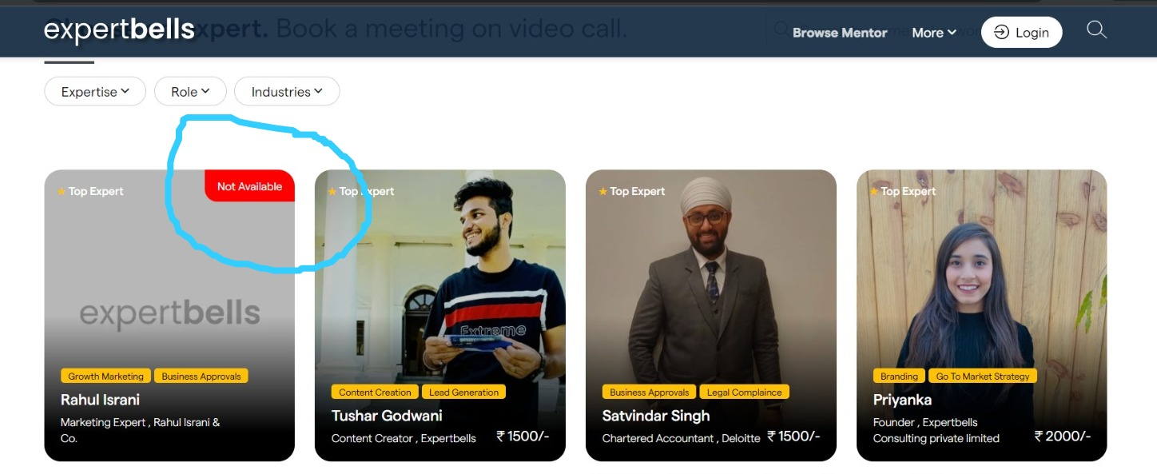

1. Please fix the issue of Email & Mobile OTP on an urgent basis.

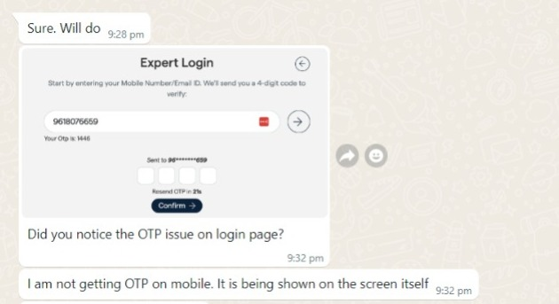

1. Copy next week wala jo option hai usme jab next month aa raha hai waha ye copy nahi ho raha hai.

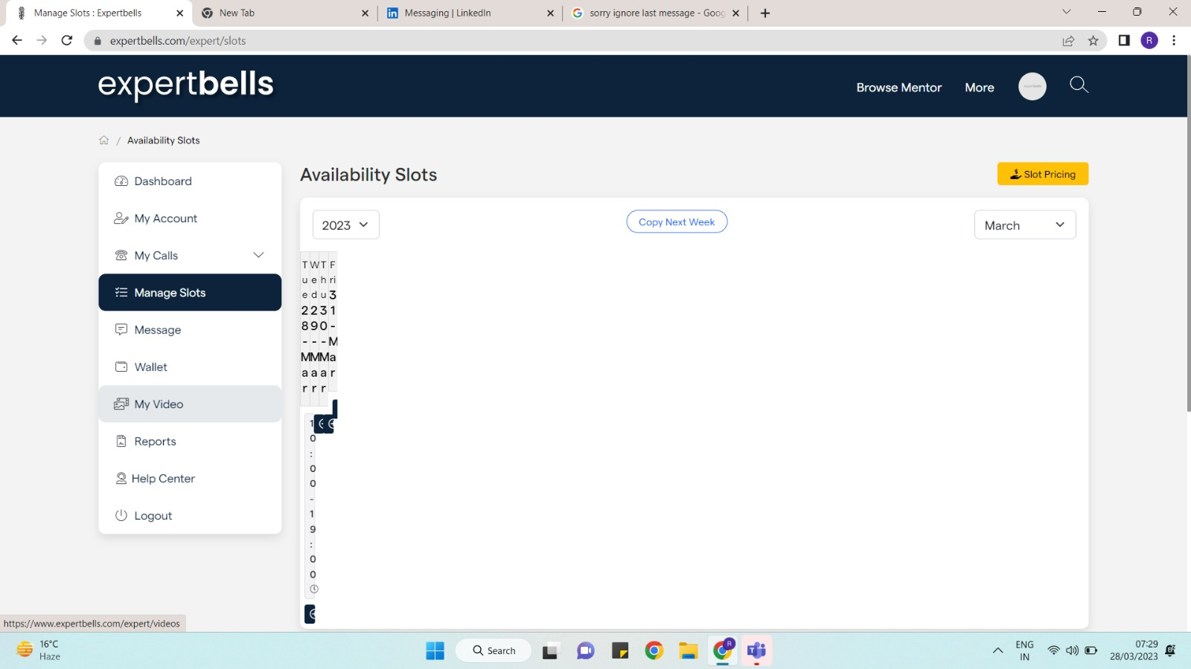

1. Company name and role ko change nahi ho rahe hai. even mai company name ko blank rakhna chahta hu. to wo bhi nahi ho raha hai. Isme company name change ho raha hai but agar mujhe yaha blank rakhna hai to wo nahi ho raha hai. and role mai to kuch bhi change nahi ho raha hai.

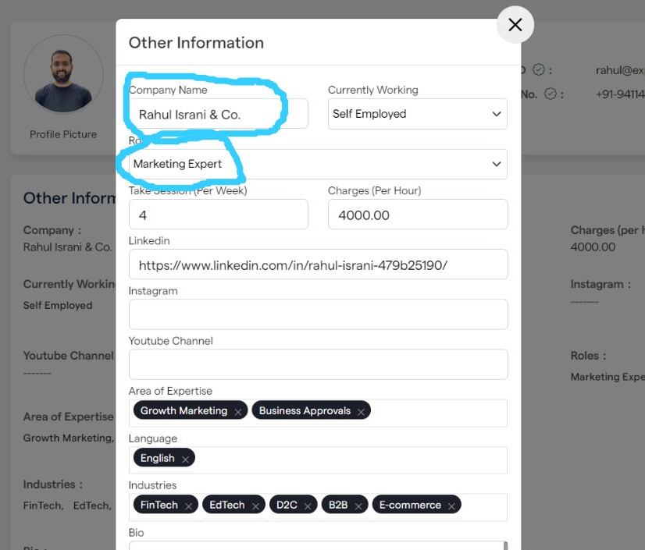

1. Remove price options in edit profile

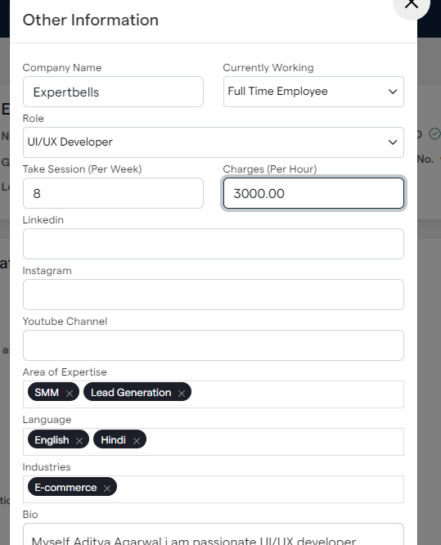

1. When we click on edit in what to expect , point which we mentioned previously is lost , so correct this bug

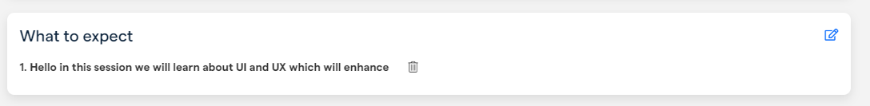

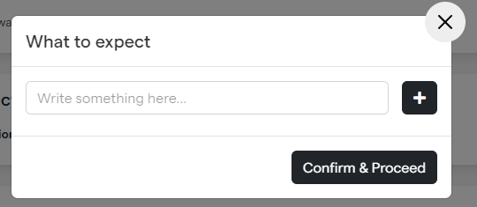

1. UI Change of “what to expect”

